Tekstbaseret eventyr

Andreas Buch, Alexsandr Sorokin, Thias Petersen dat18C

Indhold

Requirements: 1

Business Vision 1

Brief use cases 1

Fully Dressed 2

Use case diagram 3

Domain model 4

System Sequence Diagram 4

Sequence diagram 5

Class diagram 5

Forretningsgrundlag 5

SWOT 5

## Requirements:

**Person:**

* User gets control of their character.
* They play through a narrative.
* Must be able to see based on lighting.
* Can move north, east, west, south.
* Move or pick up objects based on weight.
* Move between rooms.
* Dialogue support (choosing options).
* Player can move between buildings.

**Rooms:**

* Can be dark or lit.
* Must be navigable.
* Contains interact-able items.
* Items can be visible or invisible depending on environment.

**Player:**

* User can read a description of the environment and which choices they have.
* Can interact with the world.

## Business Vision

## Brief use cases

**Use case #1 - Start menu:**

* Start and quit the game.
* Choose a name for the character.

**Use case #2 - Inventory:**

* Equipment.
* Items.
* Add/remove

**Use case #3 - Movement:**

* Pick up item.
* Inspect.
* Move.
* Go back.

**Use case #4 - Combat:**

* Damage.
* Fight or flight.
* Use items (use case #2).

**Use case #5 - Enemies:**

* Description.
* Stats.

## Fully Dressed

|  |  |
| --- | --- |
| **Properties** | **Description** |
| **Use case name** | UC #6 Choice Handler |
| **Scope** | Interaction menu |
| **Level** | User goal |
| **Primary actor** | The player who plays the game. |
| **Stakeholder** | The player - The player wants a functional game, and the choice handler will be the main focus of the game.  The game developers - have a strong interest in the game functioning as intended, and the choice handler is a big part of the game. |
| **Preconditions** | * Choice handler allows movement. * Choice handler has to work in tandem with the inventory system (UC#2). * Choice handler Has to work with the combat system (UC#4) |
| **Success guarantee** | * Scenarios load correctly. * Game must know the player location. |
| **Main success scenario** | * The choice handler will send the player to the right location. * Allow for items to be picked up and added to the inventory. * Allow for fight or flight in combat. |
| **Extensions** | * End of Map: prints generic message. * No inventory space: - Generic message. * Player dies: - game over title * Choicehandler crashes : - int as savepoints |
| **Special requirements** | * Mouse or trackpad to navigate the game. * The game must load within 10 seconds |

## Use case diagram

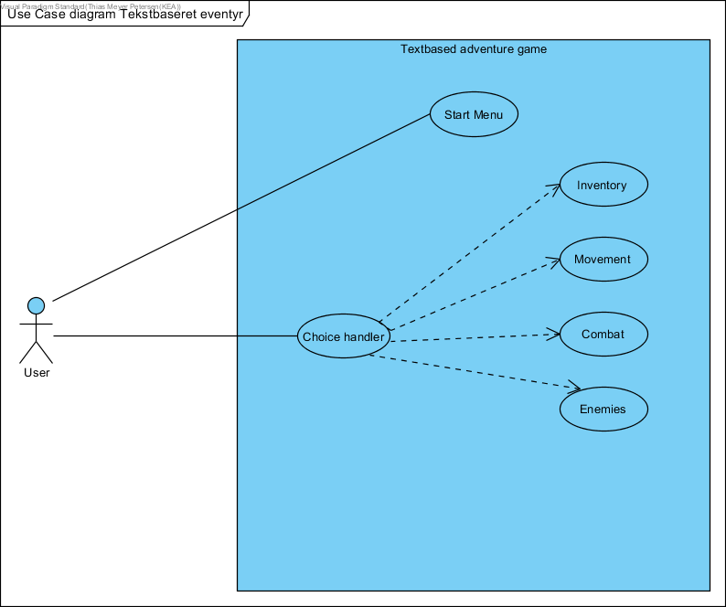

## Domain model

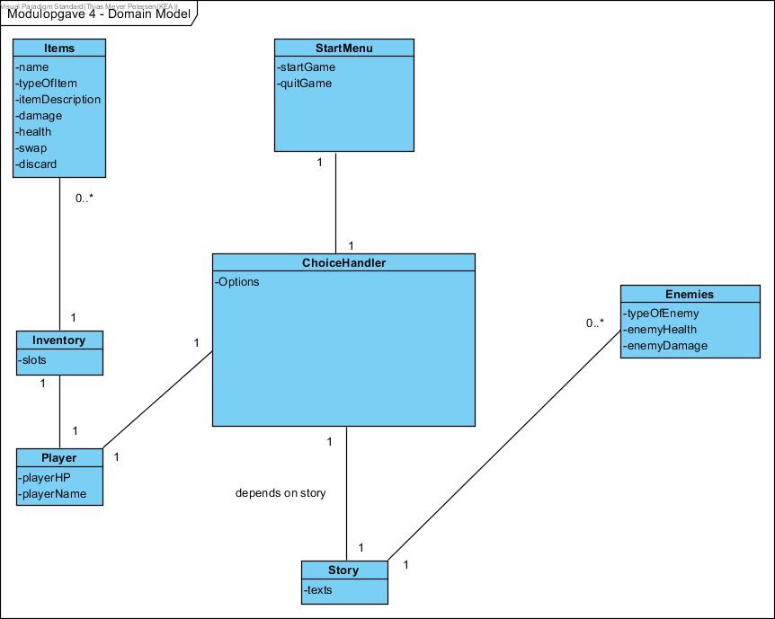

## System Sequence Diagram

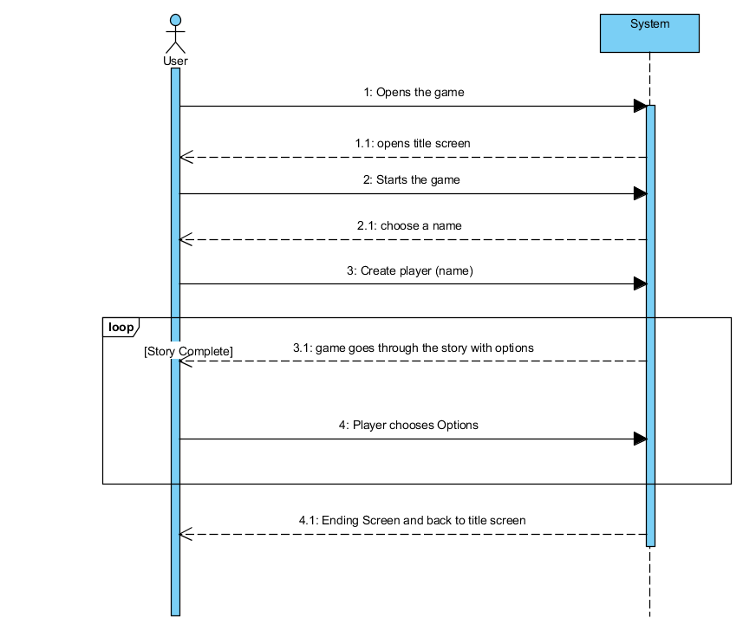

## Sequence diagram

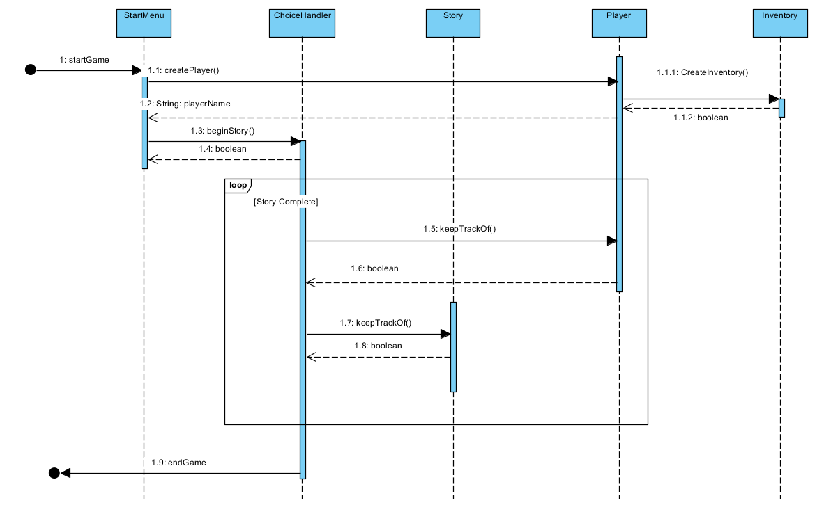

## Class diagram

## Forretningsgrundlag

## SWOT